In this lesson we will learn how to make a simple Android game using Unity Game Engine

Now, if you have been following Teacher for quite a while, you know that I have made a video on this topic

in 2017, 18, 19, and even before that.

So this time you're going to make a new and updated video.

So before starting lets look at what you gonna be building at the end of this video.

AS Teacher is showing the intro screen of the game I cannot show as udemy does not allow screenshot for this course

The intro is showing press any key to start the game

Now a game is visible where we hit the ball with pedal after it get returned by the wall and whenever we hit the ball then score is incremented by 1

Now as you can see as the ball goes down the game start again so this is the core function of the game and we are going to built it from scratch

So lets get started

OK so now lets start downloading and installing the tools that we need to build our Android game.

So now as always we are going to create our game using the Unity Game Engine so we can go to Google and search Download unity. I think the teacher is going to Download and install the tools I think the teacher is again going to show how to download and install Unity so we will skip some part of the lesson

**Note:-**

Before a few years ago, it was really hard to set up all these things( components that we install with our editor ). Now all these things come internally so that so that you don't have to do anything from the outside ( download and install component manually ).

Now this time we are going to make 2D project

The configuration for our project

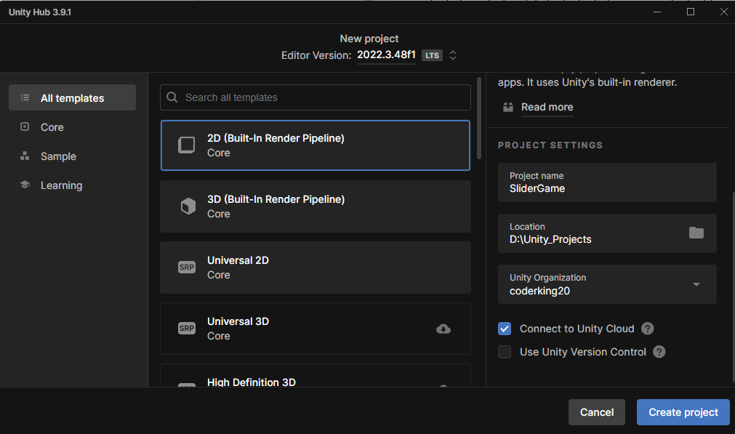

Click on create project button to create our 2d project

Teacher prefer 2 by 3 layout

So first thing you need to do is save the scene So file -> save

The time the teacher is in here we don’t need to create scenes manually we get one by default (it mean he is somewhat near to the current modern features)

Now we rename the scene Sample Scene to Game in the scene folder inside asset folder in the project panel

6:30

Now we open our build settings

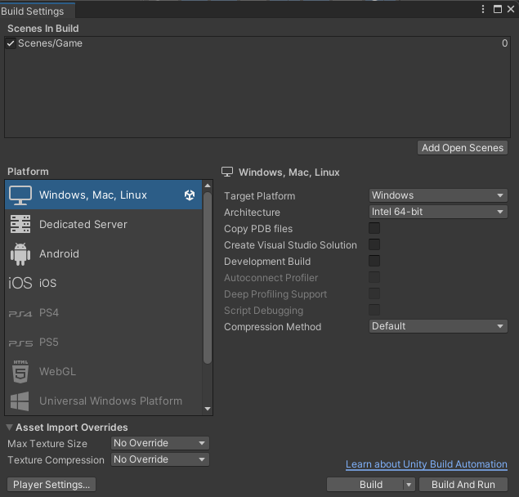

Our current platform is Window, Mac, Linux standalone but we were to build for android devices

If you have the Android version installed or the Android component installed while installing Unity then you will not be able to do this.

Now you know what you need to do if you have reached this part of the course then you know what to do.

So we switch to the Android

Now we need to select the aspect ratio for our game

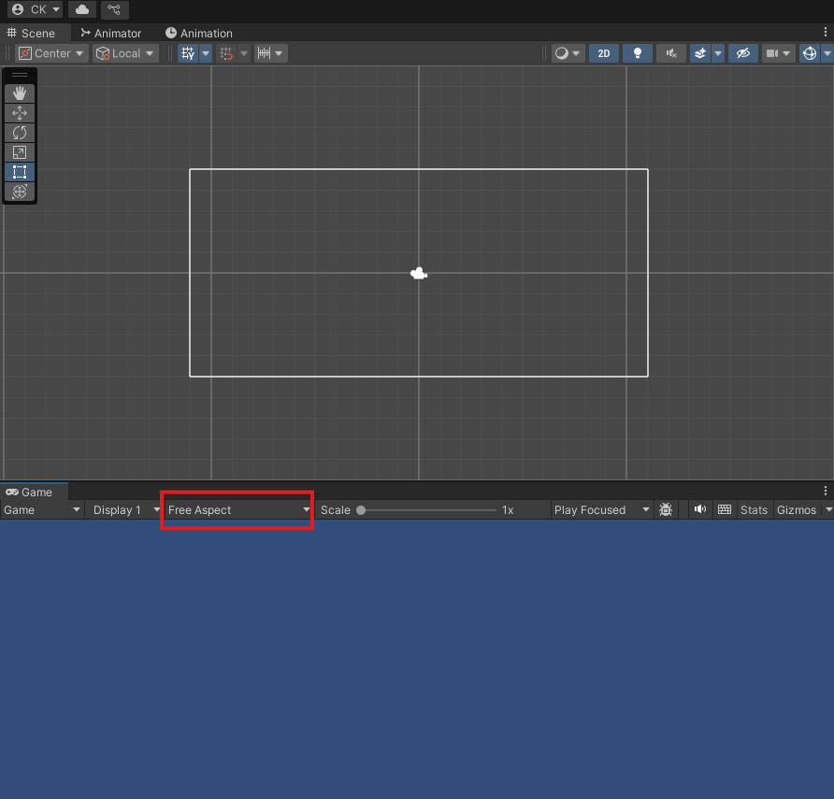

AS you can see in the marked above that the aspect ratio is Free aspect

Now click on free aspect to 1920 X 1080 Landscape(1920 X 1080) as highlighted below

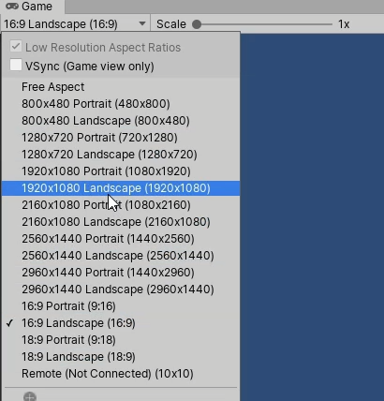

Now the game and scene panel will look like below

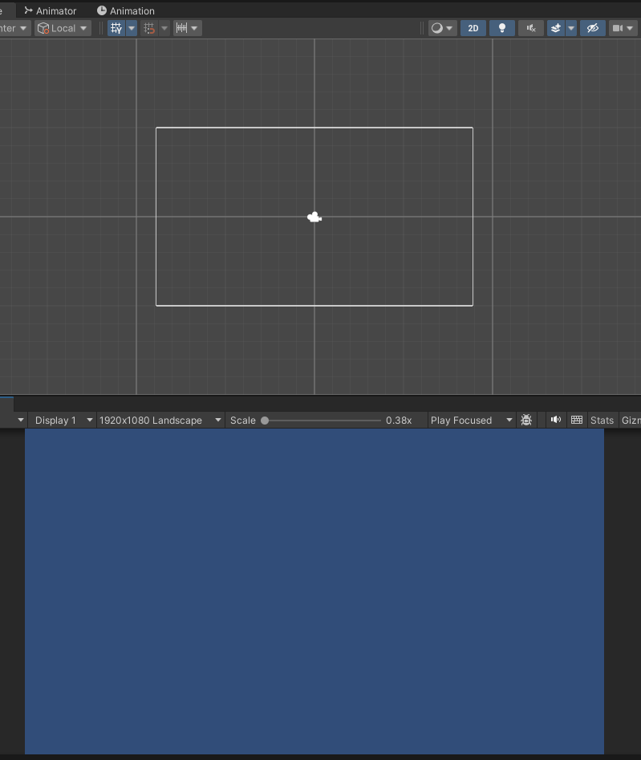

7:40

Real knowledge for making game starts from here

Now we need to start working on our game So inside the assets folder, we're going to keep all our assets are all our project elements like sprites, audios and scripts and all these things here.

So we need different folders to organize these things So here I'm going to create a new folder and I'm going to name it Sprite. We are going to keep sprites for our images.

We can also create a new folder and will name it scripts. Where are we going to keep all our scripts

Now in our hierarchy panel we have our Game scene inside which all the element of the game are present

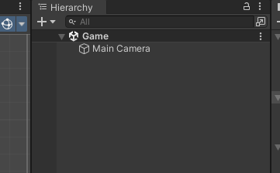

Currently we have this main camera so we select the main camera so we can select and in the inspector you can see its properties

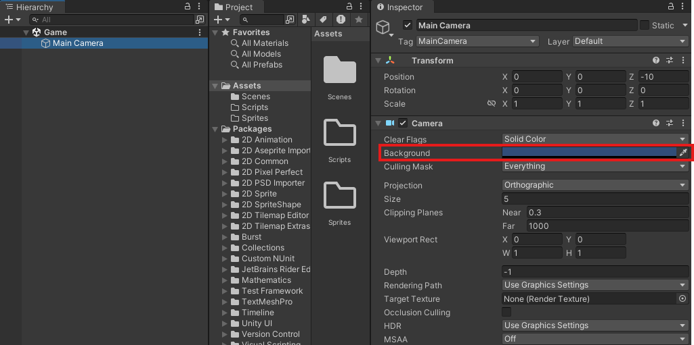

In the background as marked above here you can change the color of the background means the background you see in the screen of the game.

You can see that the clear flags is set to Solid Color ( I think it is telling the type of background )

Now set the color picker as shown below

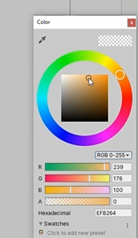

Now our game bg color look like below

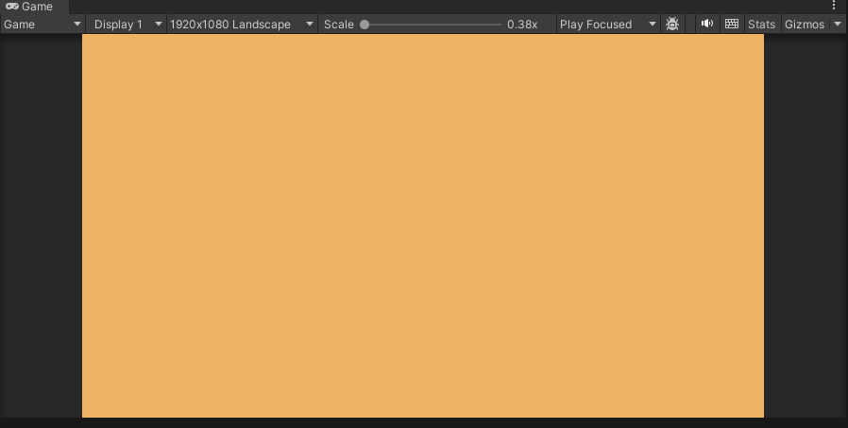

Ctrl + s to save you scene and file as well as (who knows)

So now we are going to draw boundaries for our game

Now go to sprites folder and then right click on it to open a submenu

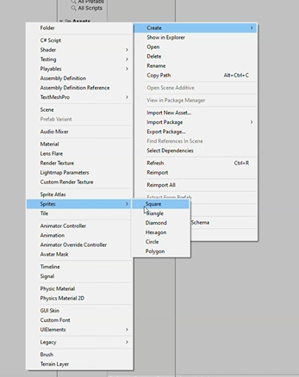

This make an image of square which we will drag on the Heirarchy to make an object but it does not work anymore we now directly place it in hierarchy

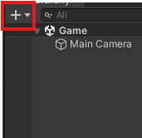

Now in submenu choose 2D object -> Sprite -> Square

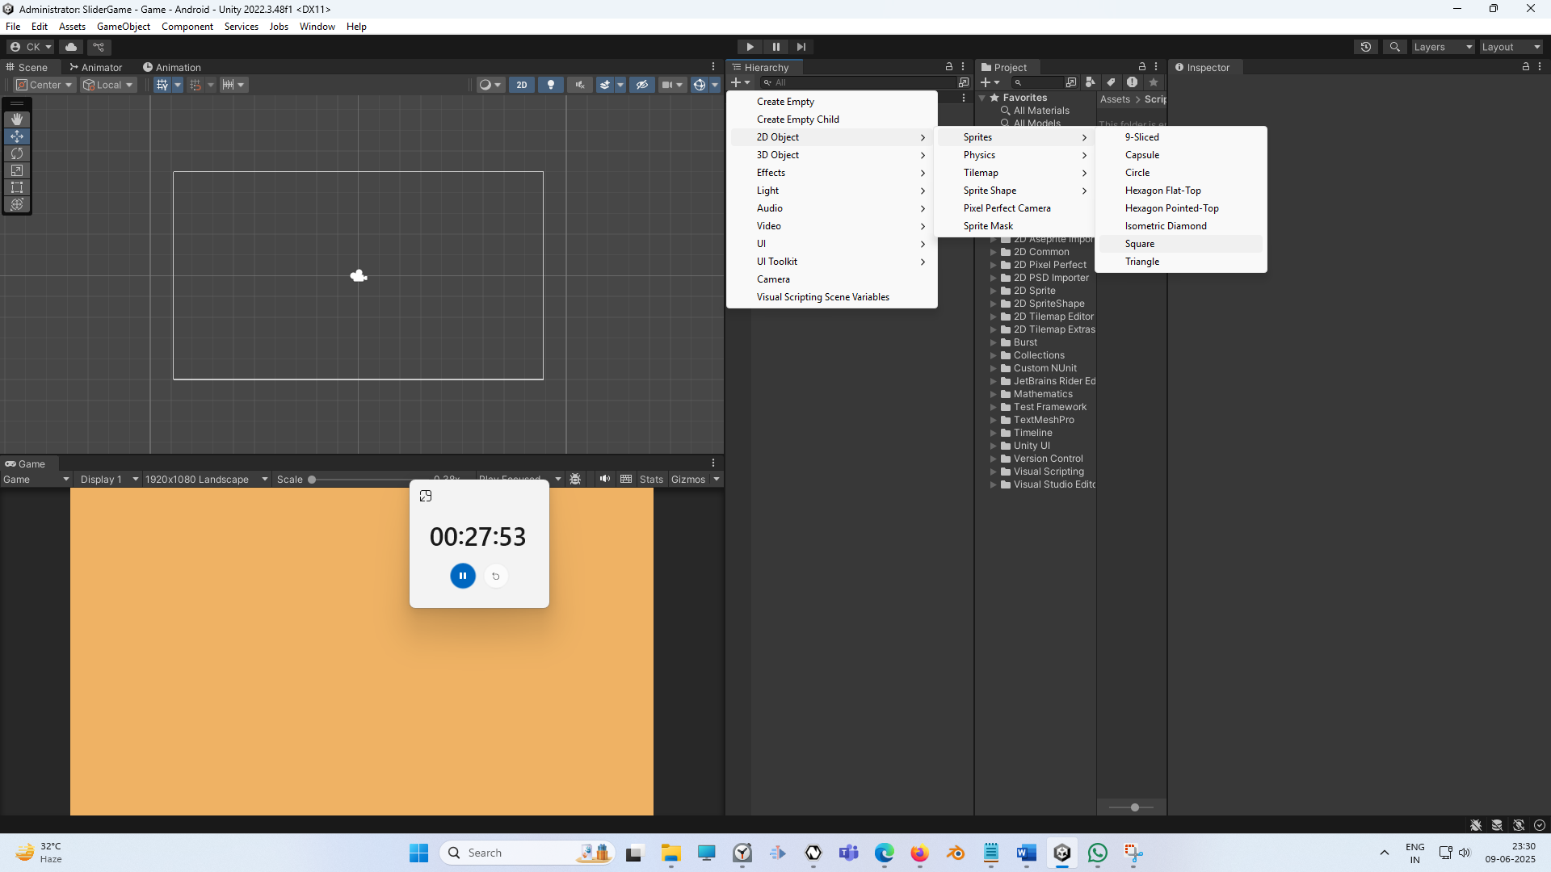

Now you can see the screen a square will be shown to us

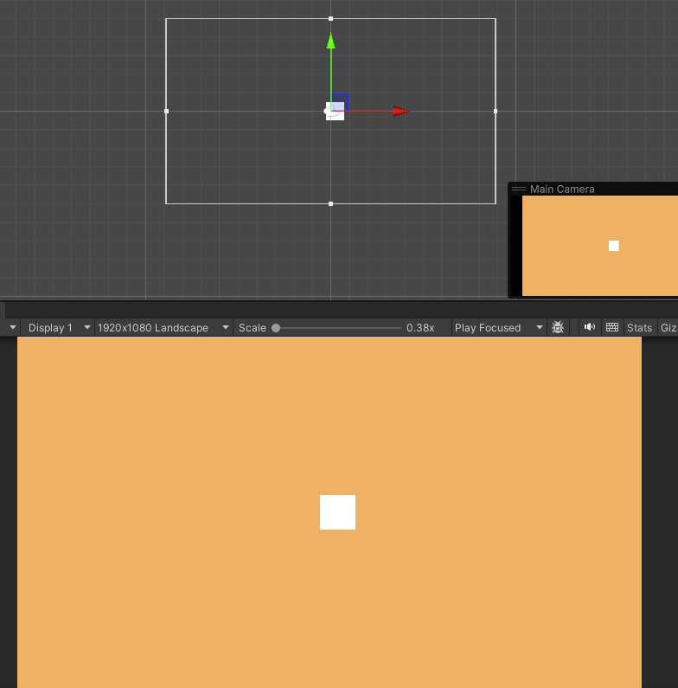

**Note:-**

Some feature are specific to platform so first switch the platform you want to work on then use the Unity

9:45

Now we have a squsare in the center

Now move the square to the top of the screen as shown below. Make sure rect tool is selected

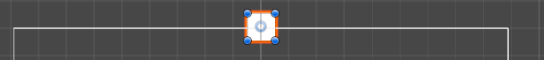

Now we can simple press the Alt button and hold it and drag it to make it bigger by dragging such that it increases in width. When we drag and then Alt then the size is increased such that the opposite is also increases in opposite direction so they grow equally in opposite direction due to which an abject size is increases uniformly as shown below

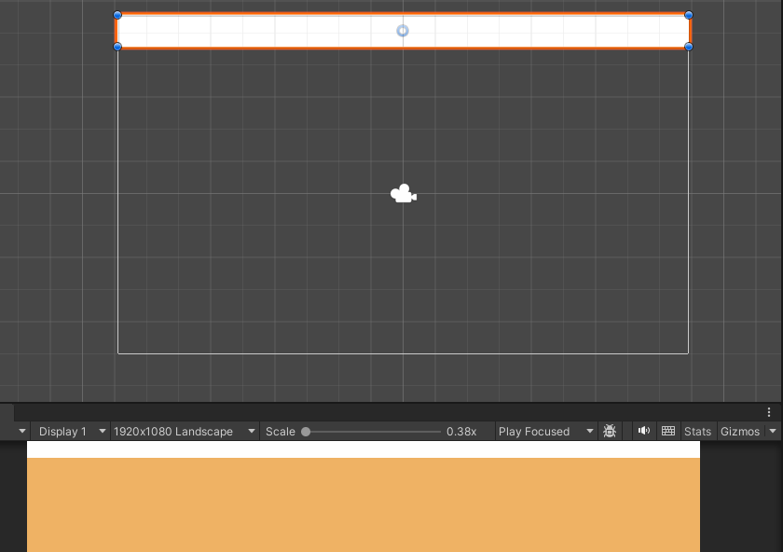

You can also do it manually

Now change the object color by clicking on the marked below

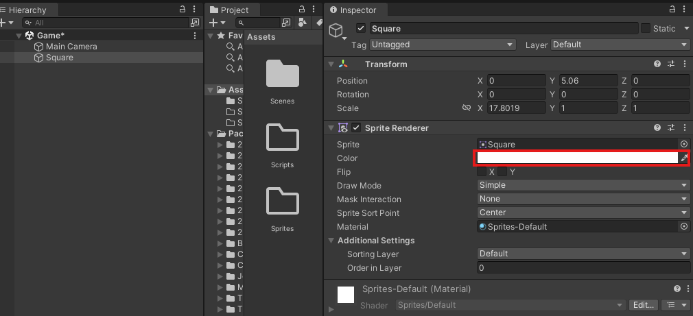

Now in color picker choose the color

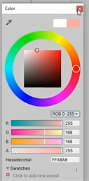

The color picker set the value as above

Now we rename the square to Boundary

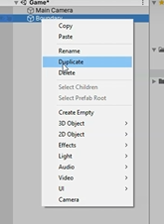

Now right click on the boundary IOA in the Heirarchy panel

**Note:-**

There is z axis in 2D unity but there are shown from 3D perspective means just seeing the same console( who knows )

Now by rotating the duplicated boundary in 90 degree in z axis and push it to the right direction until it just align with the right edge of the camera as shown below

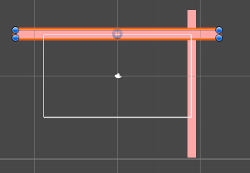

Teacher have missed one step of adding RogidBody2D by selecting the boundary IOA and then go to inspector panel and then click on Add Component and then in submenu go to physics and then to BoxCollidor2D



Now you can see above it that boundary is surrounded by green outline which covers the whole boundary IOA

Now our object will collide with other game object. So if we don't give it a boundary or if we don't give it a collider, then our balls will pass through it and they will not collide or bounce from the walls

But if we want the ball to bounce from the walls that’s why we give it a Box collider

Now we apply the box collidor to the right boundary in the similar way

Now duplicate the right boundary and set its x valuer to -ve so that it comes on the left side of the camera Now it look like below

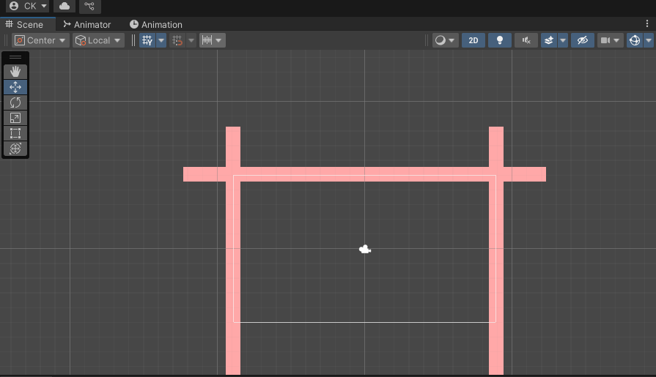

So now these things are looking pretty good and all of them have a box collidor attached to them.

So now we have created boundaries, now we need to bring the pedal and the ball in our scene.

So now we can add pedals and ball to the game

12:55

So in sprite folder we added the images of Paddles and balls you can download from any website

Add it by dragging the image over the sprites folder in project panel sass shown below

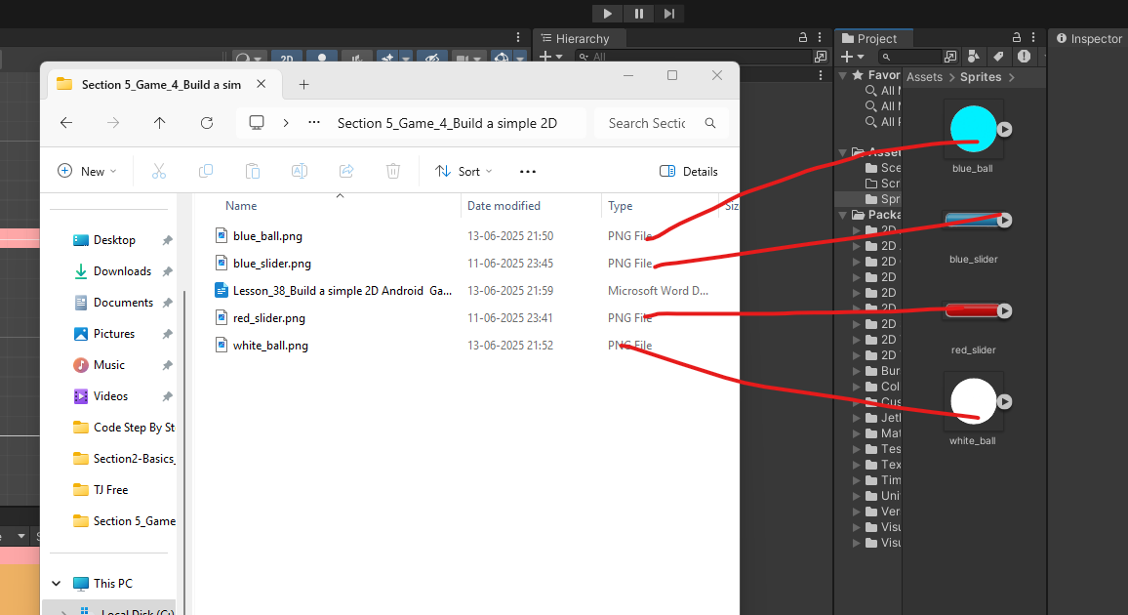

Now drag from the blue_ball image from the sprites to the hierarchy pane so that it can be included in our game or as IOA in Heirarchy(who knows)

Now we can see it in our scene and game panel that it is bigger in size

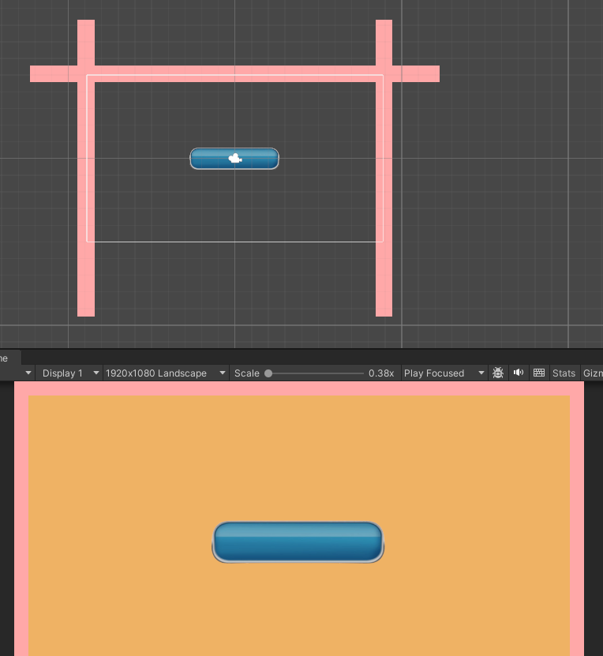

You can reduce its size by scaling tool or going to the IOA source image that is blue_pedal in sprite folder of project panel select it and then in inspector panel go to Pixels per unit and then to make it small size obviously we will choose large number so that more pixel from total pixels from an image will constitute in a unit.

Now I will turn the pixel per unit from 100 to 250 in pixels per unit as marked below

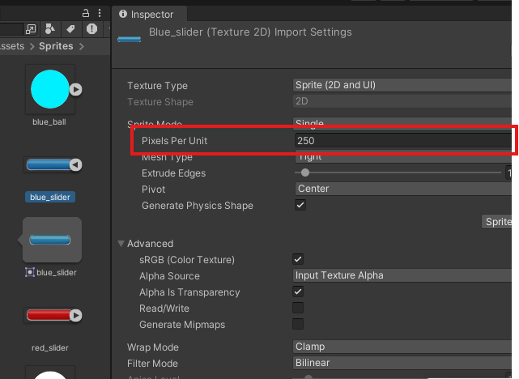

Now when you activate panel then you see popup as shown below

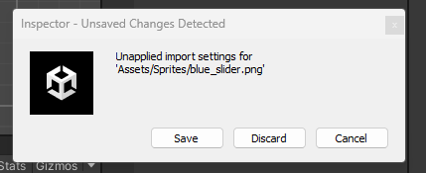

Click on save button to save the changes we have done in the inspector of that sprite so that its effect can be seen in IOA generated from it (who knows)

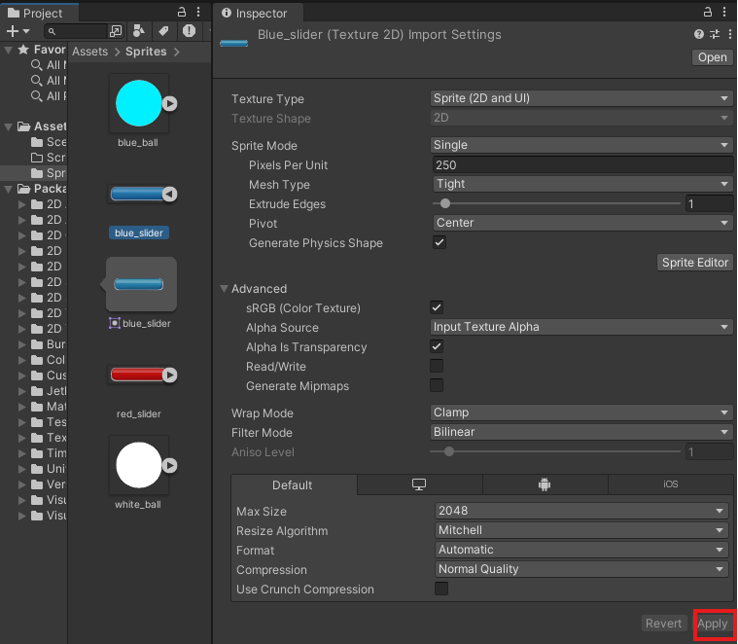

Or you can after changing the setting in Inspector you click on the apply button as marked above to being changes to the IOA generated from it.

Now our blue_pedal looks like below

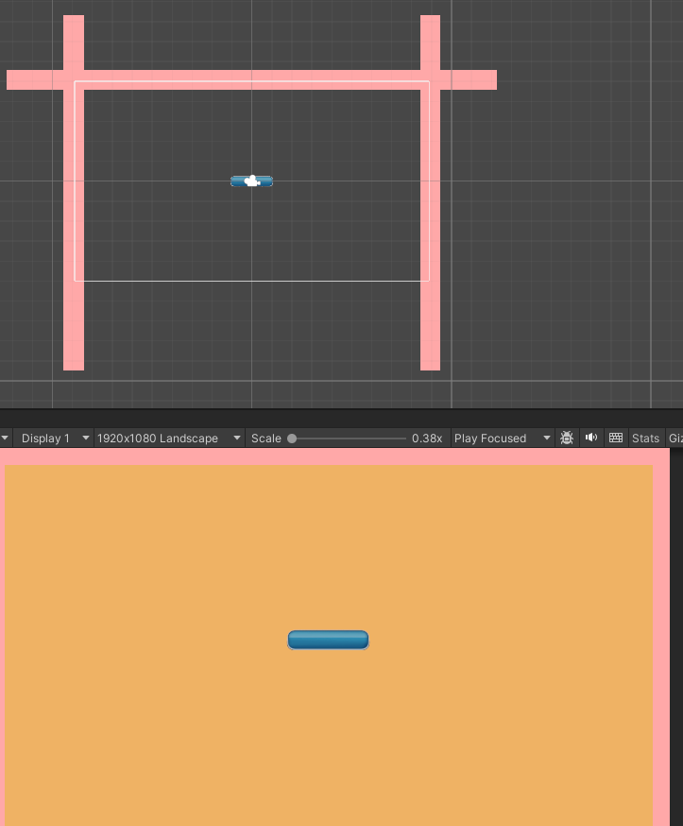

Now it is smaller in size as shown above

Now we select it move it downward until it touch the bottom edge of the screen

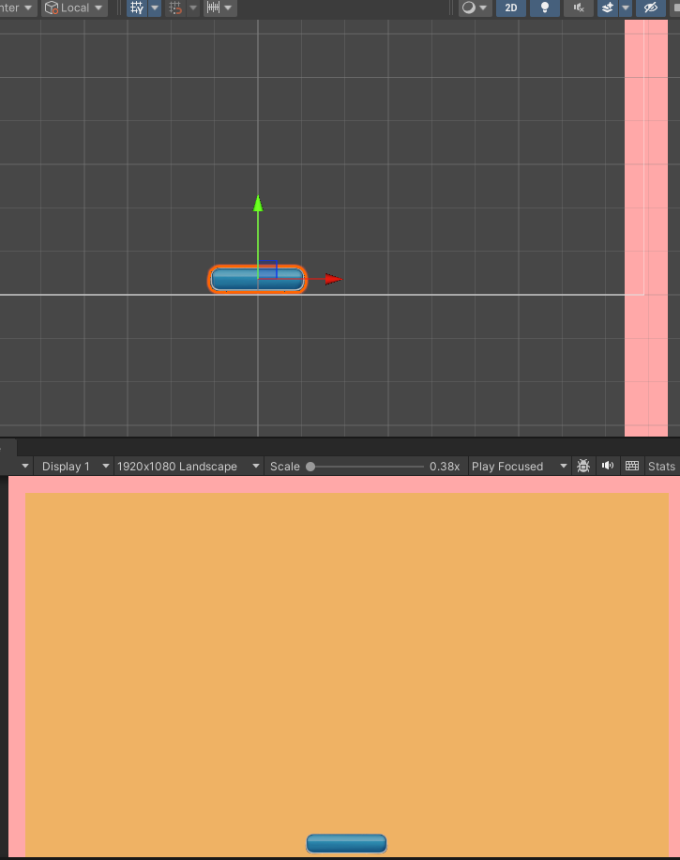

The same way we can select our ball and drag it like this. And then again make it smaller by pixel per unit property Now you can see it in your screen below

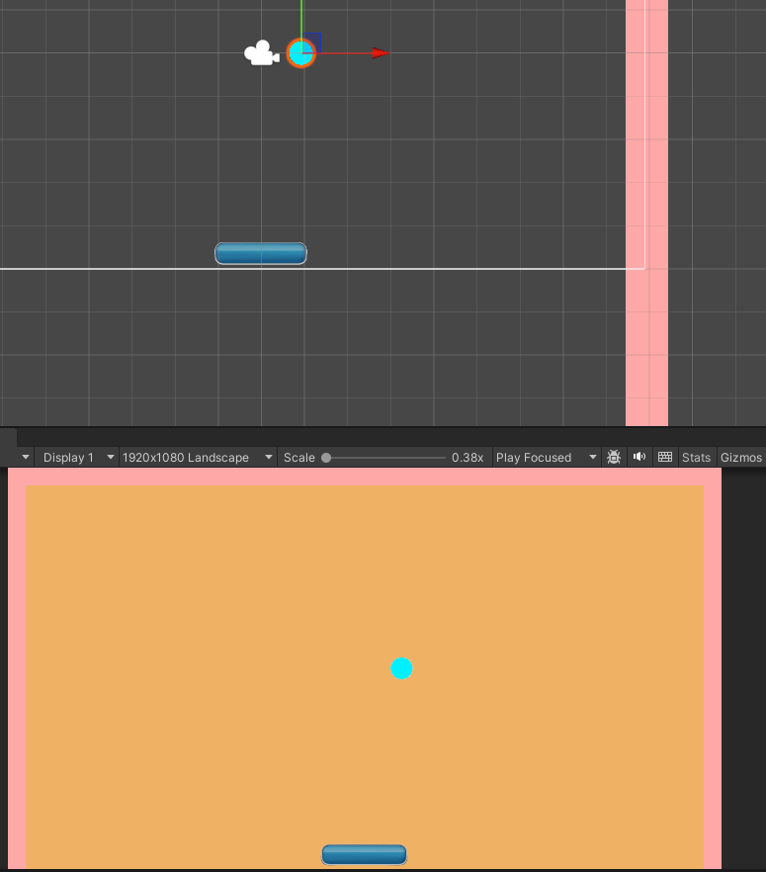

So now we have our panel as well as our ball right here on the screen Now we need to find ways so that we can move our ball, and move our medal, bounce a ball and do all these thing you want And whenever you make some changes make sure you save the scene

In hierarchy rename the blue_ball IOA to ball

Now we can add a physics component to our ball. Now we want our ball in the game to bounce, to bounce off the walls, to bounce from the pedal. And then we want to we want it to collide with the pedal and the boundaries. So that's why we need to add some physics mechanisms to the ball.

To do that in unity, we need to simply add a component called rigid body 2D

Now select the ball IOA and then in inspector panel we click on add component as marked below

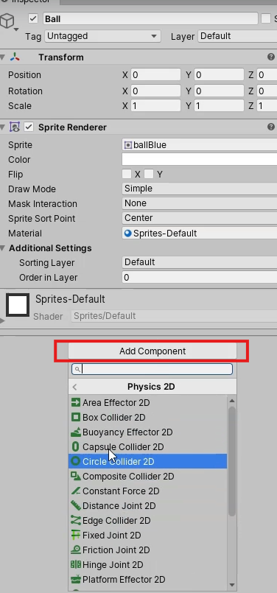

And then in submenu go to physics2D and then to RigidBody2D

when we added this body to the component, it automatically has these properties like Mass.

Drag, gravity, scale and all these things as marked below

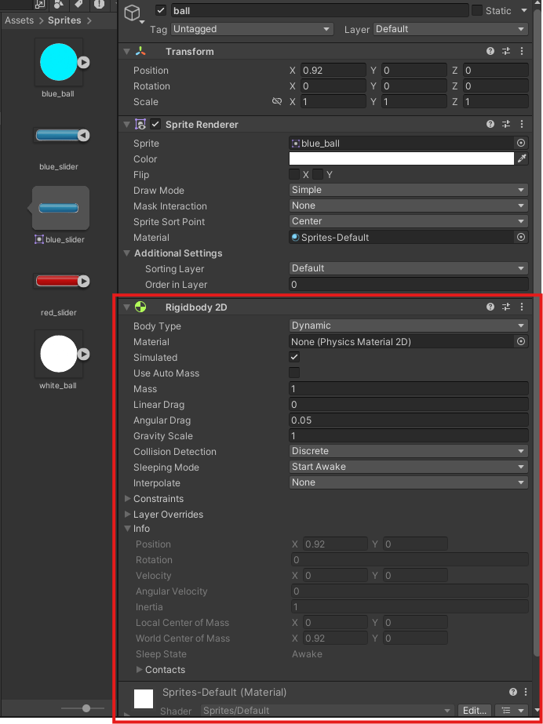

so unity’s physics engine gives this thing to us already

15:20

Or By default when we add this rigidbody to the component to any game object

Now if we press the play button then ball will drop down as shown below

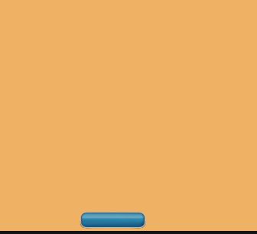

the ball is not affected by physics and that's why it is falling down.

Now, we need to give it 2D collider to the ball so that it can collide with other game objects.

So we are going to go to add component and then in submenu go to physics 2D and then to circle collider because our ball has a circular shape.

**Gizmo:-**

**A gizmo is a visual tool or widget in 2D/3D software that helps you interact with objects — usually for:**

* **Moving (Translate)**
* **Rotating**
* **Scaling**

And I think in this case camera is somewhat responsible for changing in position of the objects so that’s why teacher is calling it the gizmos

The camera was interfering with the objects so teacher make it invisible as it was a gizmos we can make it invisible by going to the marked option in the marked below menu in the scene panel

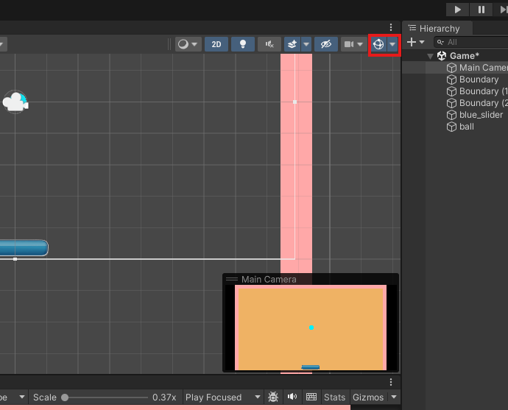

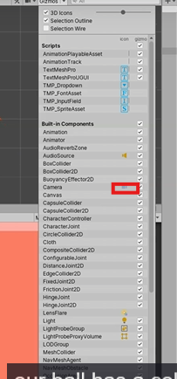

and then click on the camera icon beside the camera option in the submenu as marked above so that its internal camera icon as marked below become invisible (not disable) in the scene panel.

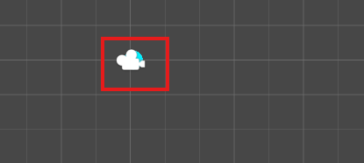

And if you uncheck the checkbox to just make its outline invisible

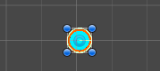

Now you can see above that the ball boundary is in green color as collider is attached to the ball

So now we have a collidor attached to the board, but still the ball will fall down because our paddle

doesn't have a collider.

All right, so now we're going to select our blue_slider and let's rename it to Pedal.

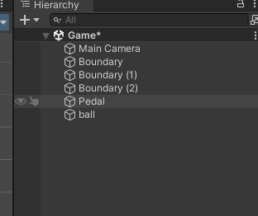

And now we go to add component and then in submenu choose Physics and then to Capsule Collidor as marked below

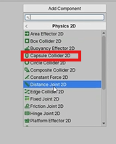

Now you can see a collider is attached to the paddle as shown below

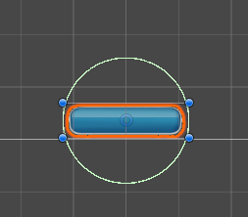

Now you can see the collider as shown above but the collide is circular in shape and its is not aligned according to the paddle boundary So we edit the shape by clicking on the edit collider option in the Capsule Collidor panel as marked below

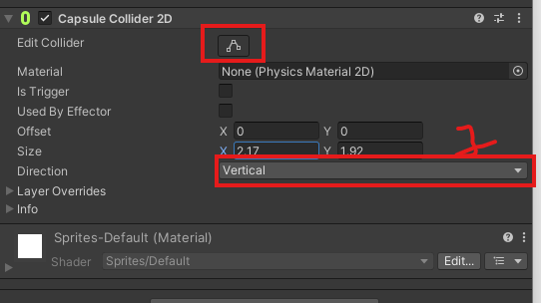

Now you can see above marked 1 that is direction there are two option that are vertical and horizontal if the vertical is chosen then if you increase the value of y field of size option above the marked 1 then only upper and bottom part will be elongated and but the left and right side will be flatten out for example if we increase the y then it will look like below

**Before**

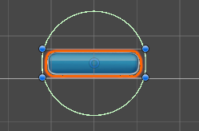

After increasing value of y

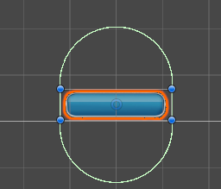

the horizontal is chosen then if you increase the value of x field of size option above the marked 1 then only left and right part will be elongated and but the top and bottom side will be flatten out for example if we increase the y then it will look like below

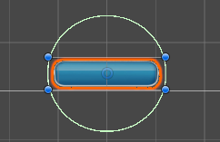

After increasing value of x

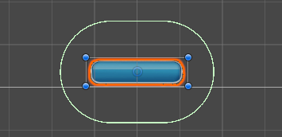

So for our paddle shape we set the direction from vertical to horizontal  
you can also use edit collider button to edit it directly (experience)

**__________________________________________________________________________________**

**Note:-**

The edit collider also get manipulated by the direction property(maybe see in future)

So now we have a nice capsule collider all around our pedal as shown below

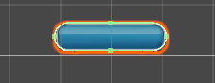

So now our panel is ready to take all the collisions. So now go ahead and click on Play

18:00